### LAB NO:05

### BASIC EVENT HANDLING:

1. Create an application which can display a Toast message by pressing a button.

**.java code:**

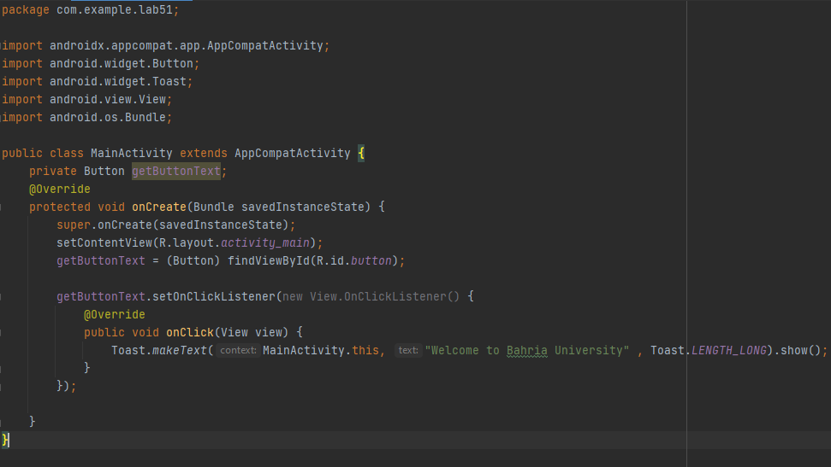

**.xml code:**

<?xml version="1.0" encoding="utf-8"?>  
<androidx.constraintlayout.widget.ConstraintLayout xmlns:android="http://schemas.android.com/apk/res/android"  
 xmlns:app="http://schemas.android.com/apk/res-auto"  
 xmlns:tools="http://schemas.android.com/tools"  
 android:layout_width="match_parent"  
 android:layout_height="match_parent"  
 tools:context=".MainActivity">  
  
 <Button  
 android:id="@+id/button"  
 android:layout_width="wrap_content"  
 android:layout_height="wrap_content"  
 android:layout_marginTop="16dp"  
 android:text="Bahria University"  
 app:layout_constraintEnd_toEndOf="parent"  
 app:layout_constraintHorizontal_bias="0.262"  
 app:layout_constraintStart_toStartOf="parent"  
 app:layout_constraintTop_toTopOf="parent" />  
  
</androidx.constraintlayout.widget.ConstraintLayout>

**OUTPUT:**

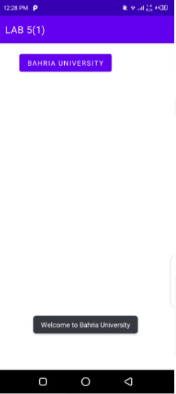

1. Create an application having three buttons. Bind those buttons with the same callback method. On pressing any button, identify which button was pressed.

**.xml code:**

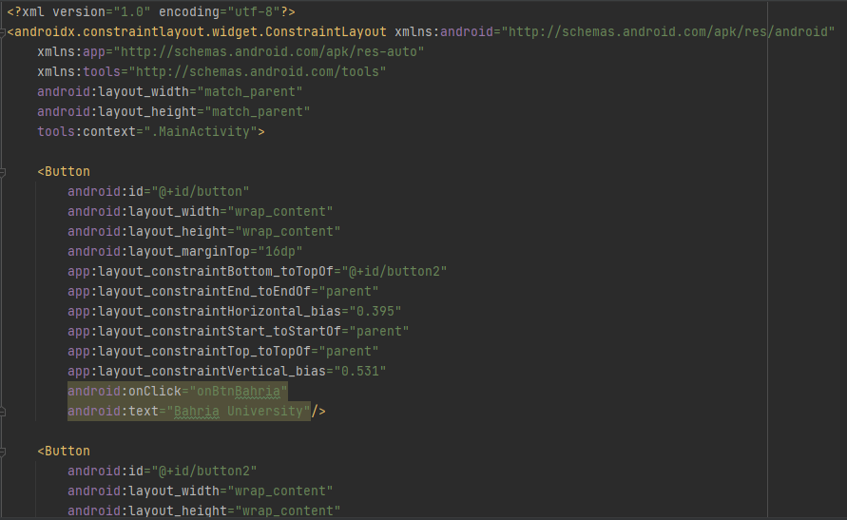

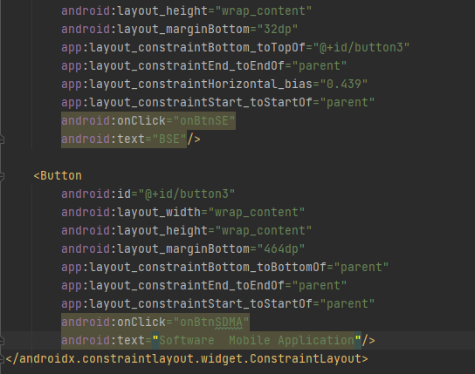

**.java code:**

package com.example.lab51;  
  
import androidx.appcompat.app.AppCompatActivity;  
import android.widget.Button;  
import android.widget.Toast;  
import android.view.View;  
import android.os.Bundle;  
  
public class MainActivity extends AppCompatActivity {  
 private Button getButtonText;  
 @Override  
 protected void onCreate(Bundle savedInstanceState) {  
 super.onCreate(savedInstanceState);  
 setContentView(R.layout.*activity_main*);  
  
 }  
 public void onBtnBahria(View view) {  
 Toast.*makeText*(getApplicationContext(), "BAHRIA...", Toast.*LENGTH_SHORT*).show();  
 }  
  
 public void onBtnSE(View view) {  
 Toast.*makeText*(getApplicationContext(), "Software Department ...", Toast.*LENGTH_SHORT*).show();  
 }  
 public void onBtnSDMA(View view) {  
 Toast.*makeText*(getApplicationContext(), "Software Application and Mobile Device ...", Toast.*LENGTH_SHORT*).show();  
 }  
}

**Output:**

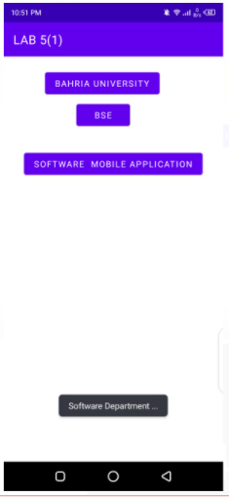

1. Create an application which takes a string message from user and create a toast of it on pressing button.

**.xml code:**

<?xml version="1.0" encoding="utf-8"?>  
<LinearLayout xmlns:android="http://schemas.android.com/apk/res/android"

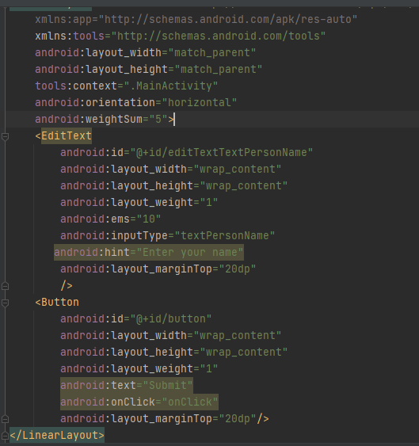

**.java code:**

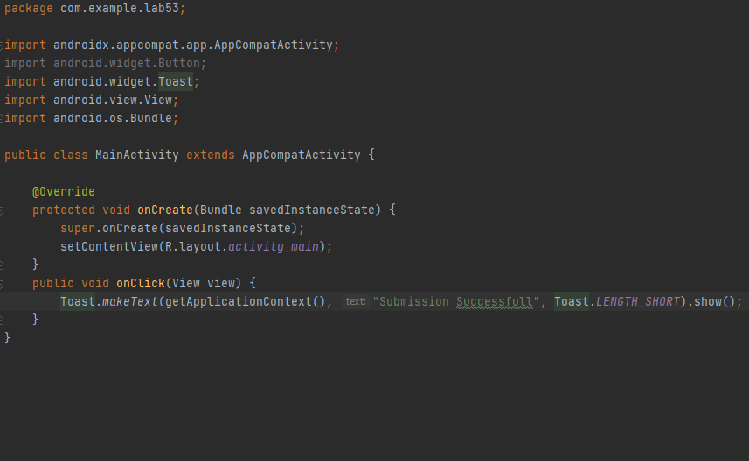

**Output:**

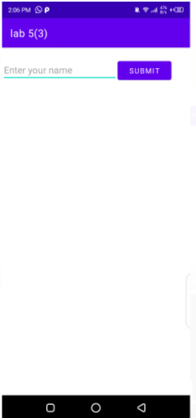

1. Create a calculator application for two integers. The output must look as follows

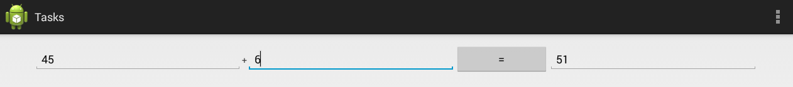

**.xml code:**

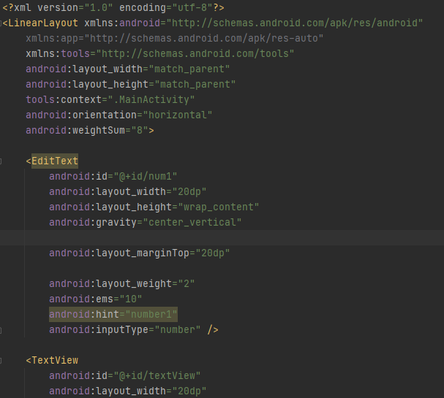

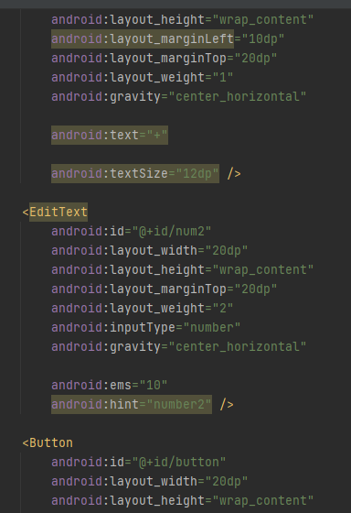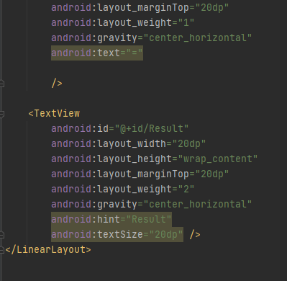

**.java code:**

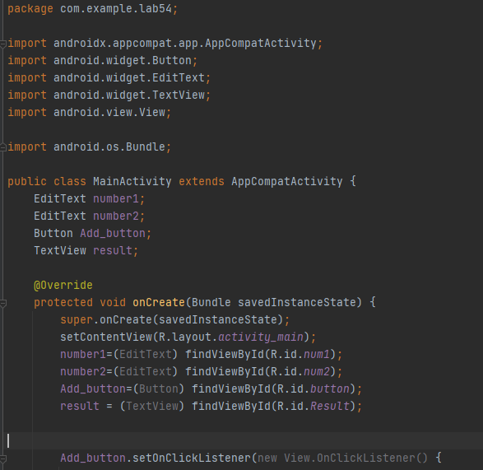

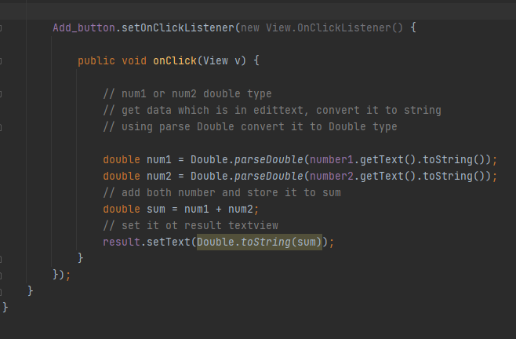

**Output:**

